WOKWI PROJECT

Link: <https://wokwi.com/projects/347658579162956371>

**OUTPUT:**

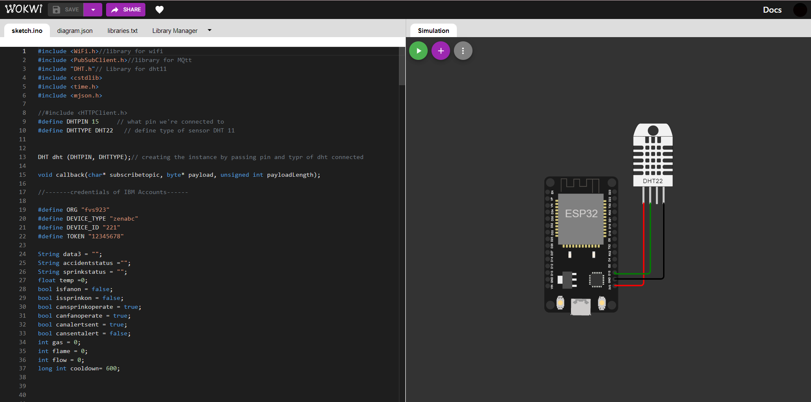

**Physical Components Used**:

* Esp32 Microcontroller
* Dht22 Temperature and Gas Sensor

**Digital Data (Random Data):**

* Flame Sensor

Flow Sensor